Homework 2

**4-1 Recurrence examples**

Give asymptotic upper and lower bounds for T(n) in each of the following recurrences. Assume that T(n) is constant for n ≤ 2. Make your bounds as tight as possible, and justify your answers.

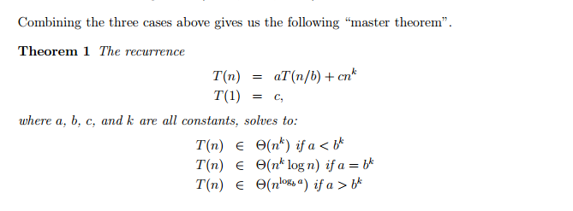

**a. T(n) = 2T(n/2) + n4.**

a = 2

b = 2

c = 4

Therefore, bc = 24 = 16

Since a < bc = 2 < 16, apply the Case 1 mentioned above in the explanation of the master theorem.

Hence, the running time of the T(n) is as follows: 🡪 Θ(nc) = Θ(n4)

**b. T(n) = T(7n/10) + n.**

a = 1

b = 10/7

c = 1

Therefore, bc = (10/7)1 = 10/7

Since a < bc = 1 < 10/7, apply the Case 1 mentioned above in the explanation of the master theorem.

Hence, the running time of the T(n) is as follows: 🡪 Θ(nc) = Θ(n)

**c. T(n) = 16T(n/4) + n2.**

a = 16

b = 4

c = 2

Therefore, bc = (4)2 = 16

Since a = bc = 16 = 16, apply the Case 2 mentioned above in the explanation of the master theorem.

Hence, the running time of the T(n) is as follows: 🡪 Θ(nc log n) = Θ(n2 log n)

**d. T(n) = 7T(n/3) + n2.**

a = 7

b = 3

c = 2

Therefore, bc = 32 = 9

Since a < bc = 7 < 9, apply the Case 1 mentioned above in the explanation of the master theorem.

Hence, the running time of the T(n) is as follows: 🡪 Θ(nc) = Θ(n2)

**e. T(n) = 7T(n/2) + n2.**

a = 7

b = 2

c = 2

Therefore, bc = 22 = 4

Since a > bc = 7 > 4, apply the Case 3 mentioned above in the explanation of the master theorem.

Hence, the running time of the T(n) is as follows: 🡪 Θ(nlogba) = Θ(nlog27)

**f. T(n) = 2T(n/4) + sqrt(n)**

a = 2

b = 4

c = 1/2

Therefore, bc = (4)1/2 = 2

Since a = bc = 2 = 2, apply the Case 2 mentioned above in the explanation of the master theorem.

Hence, the running time of the T(n) is as follows:🡪Θ(nc log n) = Θ(sqrt(n) log n) or Θ(n1/2 log n)

**g. T(n) = T(n – 2) + n2**

The relation is not of the form T(n) = aT(n/b) + f(n), hence it cannot be solved by using the master theorem. You have to solve the relation by using the expansion method.

The solution of the recurrence relation is therefore as follows:

T(n) = T (n – 2) + n2

= (T(n – 4) + n2) + n2

= ((T(n – 6) + n2) + n2) + n2

= ((T(n – n) + n2…) + n2) + n2) + n2

= ((1 + n2…) + n2) + n2) + n2

= 1 + n/2(n2)

= 1 + n3/2

Hence the running time of the algorithm is as follows: 🡪 Θ(n3)